PRODUCT DETAILS

**Guess Watch GW0057G3**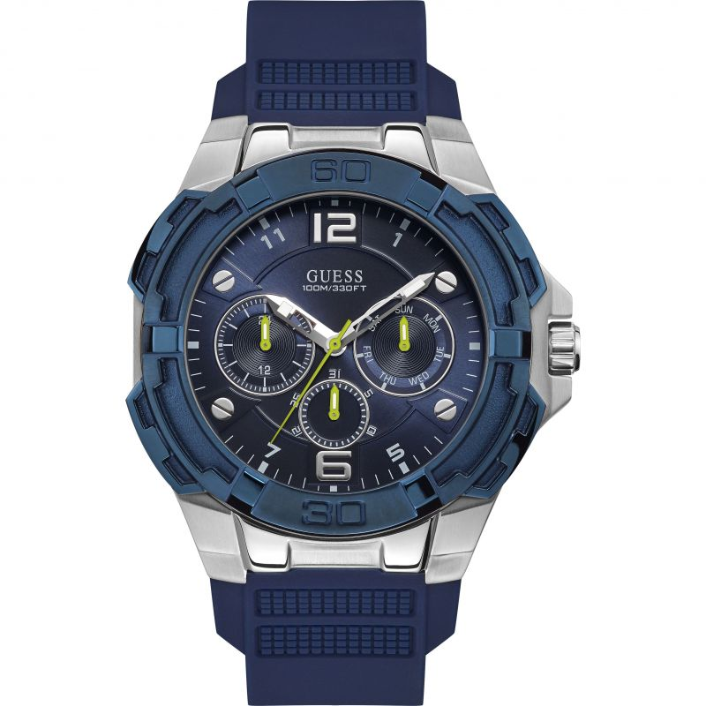

**£169.00**

**Specifications**

**Brand**: Guess

**Analogue/Digital**: Analogue

**Primary Material**: Plated Stainless Steel

**Case Shape**: Circle

**Dial Colour**: Blue

**Gender**: Gents

**Strap Type**: Rubber Strap

**BARCODE**: 091661512742

**Guarantee**: 2 years